Potential & Kinetic Energy - Student Activity Guide
When you lift a marble above the floor, you feel its weight. If that marble was as big as a basketball, you would have to lift really hard to get it up. Then it would feel like work. But even if it’s a small marble, you still have to do a little work on it to lift it up against gravity. Surprisingly, that work you put in doesn’t go away when you set the marble down higher up. Your work is stored, because now the marble is ready to fall down again. The energy it has, just sitting up there in a new, higher place, is called “potential energy.” As long as it’s there, it keeps the same amount of that potential energy. When it drops, that potential energy turns into motion, which we call “kinetic energy.” The amount of potential energy you stored is the amount of kinetic energy that comes out. In this activity, you will explore potential and kinetic energy.

These directions will get you started. Your teacher will be in contact to guide you and provide information.

Materials From The Bag
- Plastic tube
- Marble
- Steel Ball
- Wooden Ball
- 2 tape measures
- 4 x 6 Index Card
- Post-It Notes
Preparation: Ramp Set-Up
The ramp set-up will be used in all three parts of this lesson.
- Find a smooth, flat place a little longer than a meter. A countertop, floor, or table will work. Use a tape measure to be sure it’s long enough.

- To make a starting line for the ramp, stick a post-it note to the table. The edge with more than a meter out in front of it is the start and line. It looks like this:
start line
more than a meter
room for
books

post-it

- Put one end of the tube on the start line and use some books to lift the other end of the tube so that it slopes down from the books to the start line. Fold an index card in half lengthwise, then fold it again in the middle of its length to make a “V.” Place the V at the bottom of the tube as in the diagram on the other side of this page.

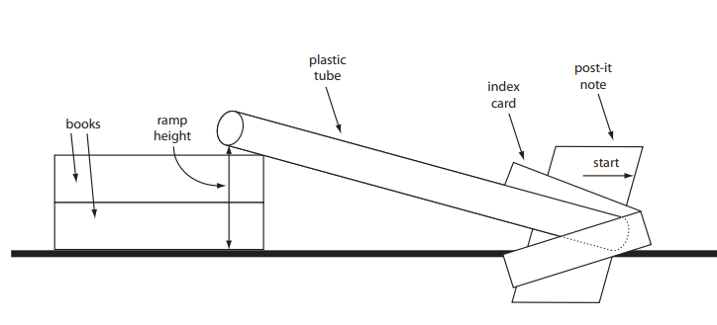

- To change the height of the ramp, move the books closer to or farther from the start line. Measure the height of your ramp with the measuring tape (from the bottom of the tube to the surface of the table).

Part 1: How Does Height Affect Kinetic Energy?
In this part, we explore how height affects kinetic energy. We will measure the amount of kinetic energy by how far the rolling marble moves the folded index card from the start line.
- Choose 3 heights from which to roll the marble. You will roll 3 times from each height and record how far the index card travels as the results. Test heights may range from 30-150 mm.
- Test, collect, and record data. Choose the median distance for each height.
How did the height of the marble affect the distance the card traveled? Review the definitions from the introduction and give examples of potential and kinetic energy of the marble.

Part 2: How Does Mass Affect Kinetic Energy?
In this part, we explore how mass affects kinetic energy. Mass is how heavy something is. Roll 3 different balls: wood, glass marble, & steel down the tube. Each ball has a different weight: wood 1.5g, glass marble 4.8g, steel 16.3g.
- Make a prediction:
  - Which ball will push the card farthest? How far do you expect it to go?
  - Which ball will push the card the shortest distance? How far do you expect it to go?
- Set the ramp to 100mm. Roll the glass marble and record how far the card travels. Do this three times, record your data, and choose the median distance for each ball. The median is the middle distance.
- Repeat step 2 with the steel and wooden balls.
How did the mass of the ball affect how far the card traveled? What else might have affected the results?

Part 3: Hit The Mark!
In this part, try to solve the challenge in as few trials as possible. Use all the data you collected in Part 1 and 2.
Challenge: Using the steel ball, what ramp height will cause the folded index card to travel 58cm? (Allow a range of 570-590 mm).
When the steel ball travels between 570-590mm, you hit the mark! What was the height?

